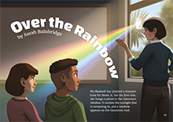
Connected
Level 3
2016

Over the Rainbow
by Sarah Bainbridge

Overview
In this article, students explore the different types of energy along the electromagnetic spectrum and research how this energy can be used in their everyday lives.
A Google Slides version of this article is available at www.connected.tki.org.nz.

Science capability: interpret representations

SCIENCE: Nature of Science: Communicating in science  Level 3 – Begin to use a range of scientific symbols, conventions, and vocabulary. | Key Nature of Science ideas  - Scientists use models and diagrams to help them understand and explain things we cannot see  - Understandings can lead to technological developments.
SCIENCE: Physical World: Physical inquiry and physics concepts  Level 3 – Explore, describe, and represent patterns and trends for everyday examples of physical phenomena, such as … light … and waves. For example, identify and describe everyday examples of sources of energy, forms of energy, and energy transformations. | Key science ideas  - Energy travels in waves.  - Many forms of energy are invisible.  - Light is electromagnetic energy.  - We use instruments to detect and measure electromagnetic energy we can't see with our eyes.
ENGLISH: Reading  Level 3 – Ideas: Students will show developing understanding of ideas within, across, and beyond texts. | Indicators  - Uses their personal experience and world and literacy knowledge confidently to make meaning from texts.  - Makes meaning of increasingly complex texts by identifying main and subsidiary ideas in them.  - Starts to make connections by thinking about underlying ideas in and between texts.  - Makes and supports inferences from texts with increasing independence.

The New Zealand Curriculum

Science capability: interpret representations

Capability overview
Scientists represent their ideas in a variety of ways. They might use models, graphs, charts, diagrams, photographs, and written text. A model is a representation of an idea, an object, a process, or a system. Scientists often use models when something is not directly observable. Models enable scientists to work on their ideas, even though they are often using a limited representation of the “thing” itself. It is important students can identify what is the same and what is different about the model and the thing. | It is important for students to think about how data is presented and ask questions such as:  - What does this representation tell us?  - What is left out?  - How does this representation get the message across?  - Why is it presented in this particular way?  This sort of questioning provides a foundation to critically interact with ideas about science in the media and to participate as critical, informed, and responsible citizens in a society where science plays a significant role.

More about the capability

The capability in action
The science capability “Interpret representations” is about students understanding information that is presented as a description or in visual form and recognising the best way to present information.  Scientific representations include diagrams, models, charts, and graphs, as well as written text.  Scientists develop models and diagrams that best represent their theories and explanations.  Scientists  Scientists use:  - representations that can help both the original scientist and others clarify, critique, and evaluate their ideas, research, and theories  - computer and other kinds of modelling to predict what might happen in certain conditions and then test these predictions to see how accurate the model or idea is  - diagrams or models to communicate science ideas  - graphs to present data  - scientific forms of text involving argumentation that use evidence to debate explanations.  Students  Students should have opportunities to:  - learn to interpret a variety of representations, including models, diagrams, graphs, and text  - develop their own representations of scientific ideas, for example, through modelling using concrete materials or using their own bodies in mime and drama  - recognise how the model or representation matches the science idea and how it is different  - consider and critique a range of representations, including scientific texts, newspaper articles about scientific matters, online information about science matters, and scientific representations developed by their peers. | Teachers  Teachers can:  - help students to be more critical consumers of science information by being explicitly critical themselves and modelling useful questions  - support students to evaluate how information is presented, for example, to assess if a graphical representation has been done appropriately or is it misleading  - ask questions such as:  - What do you think this representation tells us?  - What do the (arrows, lines, symbols, etc.) mean? (that is, help your students interpret the features)  - Is anything left out? Do you think anything is missing?  - How does this get the message across?  - Is there anything more you need to know to be able to interpret this representation?  - How does the representation make the science idea clear?  - Which aspects of this representation could mislead the reader?  - Why is it presented in this way?  - Could you suggest a better way to represent it?  - establish a science classroom culture by:  - modelling and encouraging a critical stance  - encouraging students to consider the quality and interpretation of scientific representations  - introducing learning conversations that involve interpreting, critiquing, and developing representations to demonstrate the idea's relevance in everyday life.

More activities to develop the capability

Meeting the literacy challenges

The literacy demands of this text lie in understanding the complex vocabulary and explanations around electromagnetism, which is embedded in a running narrative about a class exploring this concept. Students will need to use their knowledge of scientific prefixes, compound words, and word families to build their understanding. They will also need to read the text closely, noting down key information and ideas, to build their understanding of the science ideas.  Another literacy demand lies in the requirement for students to make inferences about the content of each section. The headings, diagrams, text boxes, and illustrations support students to infer the key ideas of each section. | The following strategies will support students to understand, respond to, and think critically about the information and ideas in the text.  You may wish to use shared or guided reading, or a mixture of both, depending on your students’ reading expertise and background knowledge.  After reading the text, support students to explore the activities outlined in the following pages.

INSTRUCTIONAL STRATEGIES

Understanding and using scientific terminology  There are some challenging scientific concepts in this article, so it is likely that you will need to scaffold your students to work out the meaning of each one. The goal is for the students to use the scientific words confidently. Model using the words and provide plenty of opportunities for the students to use them in their speaking and writing.  EXPLAIN that this article follows a class, which is very like your own, as they explore different kinds of electromagnetic energy and the ways we use this energy. The class in the story studied electromagnetic energy the previous year, and they used that knowledge to help them with their research. PROMPT your students to make connections to their own knowledge of this subject.  What do you already know about electromagnetic energy? What are some key words you might need to use when talking about electromagnetic energy?  Skim through the article, looking at the headings and diagrams and running your eyes over the text. What are some other important words that are related to this topic?  LIST the topic words and phrases the students have noticed, then DISCUSS how a reader could work out the meanings of these words and phrases. RECORD these strategies so that the students are reminded of them as they read. Some of these strategies may require modelling. These may include:  - Knowing the word from another context  - Finding a clue in the text  - Looking at the structure of a compound word (for example, "infra/red", "ultra/violet", "electro/magnetic", "wave/length")  - Noticing word families (for example, "electromagnetic spectrum", "electromagnetic wave"; "radio wave", "radio telescope"; "electromagnetic rays", "gamma rays", "X-rays")  - Checking the glossary  - Finding the meaning from a picture or diagram  - Using a reference tool, such as a dictionary, thesaurus, or the Internet. | Draw up a three-column table under the heading “Vocabulary about electromagnetic energy” and model how to predict what the word might mean, based on prior knowledge of the concepts and the vocabulary. You may need to show them how you break the words into its components, using the prefix “electro” and the word “magnetic”. Have the students work in groups to list different technical terms in the first column. Encourage them to brainstorm in groups what each term might mean and list the suggested definitions for each in the second column. They could then revise their definitions when they finish reading and list their learning in the third column.  Vocabulary about electromagnetic energy  Topic vocabulary What we think the term means What we now know it means  Electromagnetic spectrum  Use the words below to make sets of cards that the students can use to REVIEW what they have learnt. Have the students work in pairs to organise the energy cards according to their place on the spectrum and then record how we use that energy.  Type of energy Length of wavelength Use  Radio waves The longest wavelengths on the spectrum Cellphones, radios, televisions, ratio telescopes  Infrared energy Slightly longer wavelength than visible light Solar panels, infrared cameras  Ultraviolet energy Slightly shorter wavelength than visible light Solar panels  Gamma rays Shortest wavelengths on the spectrum Destroying pests or diseases and helping food last longer (called “irradiation”), radiation therapy  The students could then check the order of their cards against the diagram on pages 18 to 19. Then have them practice putting their new vocabulary to use by taking turns to make statements about each of the cards.

Meeting the literacy challenges

TEACHER SUPPORT
Energy travels in waves.  Understandings can lead to technological developments. | Scientists use diagrams to help them understand and explain things we cannot see.  .  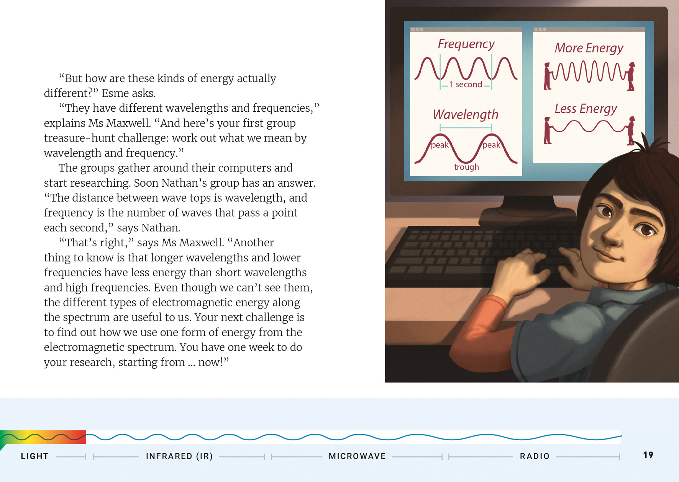  Light is electromagnetic energy.

Reading standard: by the end of year 6
The Literacy Learning Progressions
Effective Literacy Practice: years 5–8

Learning activities – Exploring the science
The following activities are a guide for supporting students to explore and develop understandings about the science capability “Interpret representations”. Some activities focus directly on the science capability. Other activities extend students’ content knowledge across the learning areas. Adapt these activities to support your students’ learning needs.

Activity 1 – Microwaves and X-rays
Two types of electromagnetic energy are not discussed in the article: microwaves and X-rays. The students could work in groups to investigate the uses of these forms of electromagnetic energy and report on their findings to the rest of the class. Challenge them to follow the examples of the students in the article and think of imaginative ways they could share their learning.
Encourage the students to confirm their learning using vocabulary cards like the ones you created at the start of the reading. The students could work in pairs to create a set of cards that relate to their chosen type of energy. They could use these cards to make a summative statement about that energy type and then share it with another pair of students. The statement would include the type of energy, the length of that energy’s wavelength, and how that type of energy is used.

Activity 2 – Going deeper
This article only provides a brief overview of electromagnetic energy. Prompt the students to discuss any questions they have. Allow them to work in pairs or groups and to select one particular type of energy to investigate further. Have them discuss and select a question or questions that they will attempt to answer in their research. For example:
- How do cellphone towers or solar panels collect electromagnetic energy?
- Are there risks to human health in using a particular type of electromagnetic energy?
- Who first worked out how to use a particular form of electromagnetic energy? How did they work this out?
- Are scientists researching other ways of collecting a particular form of electromagnetic energy? Why?
See "Resource links" below for useful starting points for this research. There may also be useful contacts in your local community. Encourage the students to think of people they know who work with that type of energy.
As you move around the groups, encourage them to discuss the most appropriate way to share what they have discovered with the rest of the class.
Based on what you have learnt so far, what will be the key messages you want to get across to your audience?
What might be a good way of communicating those messages?

Activity 3 – Rainbow connection
Most students will have seen what happens when a prism captures light and reflects that light to create a rainbow. This is an intriguing phenomenon, and the students are likely to be interested in exploring it further.
See “Resource links” for details on several issues of the Building Science Concepts series that explore light and colour. Book 10, Light and Colour: Our Vision of the World, section four, activities 1 and 2, provide opportunities for students to investigate the full spectrum of visible light. These activities help students to create their own prisms.
Book 11, Seeing Colours: The Spectrum, the Eye, and the Brain, sections two and three, includes activities that allow students to learn how particular colours in visible light can be produced by blocking off some parts of the visible spectrum. They can also explore how an object’s colour is derived from the way the object reflects and absorbs different colours.
“Colours of Light” is a page on the Science Learning Hub that discusses visible light. It includes links to interactive activities on mixing primary colours.
The section on “Colour and Light” in Making Better Sense of the Physical World includes a set of activities that examine how rainbows are formed and why there are coloured patterns on bubbles.

Extending the learning
Having explored colour and light as a class, groups of students could go on to investigate other features of light by researching questions such as:
How do we see?
What happens when light hits a solid object?
Why are people so interested in the “speed of light”?
You could also ask students to draw diagrams to explain what they have found out.
Explore infrared and ultraviolet light using multimeters. The website, http://www.nexusresearchgroup.com/technical-data/multimeter-sensors.htm, shows students how to use simple multimeters and LEDs to detect ultraviolet and infrared light. Students can check their surroundings to detect the presence of these wavelengths of light and compare them with sunlight.

Learning activities – Exploring the science

RESOURCE LINKS

Building Science Concepts  Book 9 – Shadows: Effects of the Absence of Light  Book 10 – Light and Colour: Our Vision of the World  Book 11 – Seeing Colours: The Spectrum, the Eye, and the Brain  Making Better Sense of the Physical World  “Light and colour” – pages 35–54  Connected  “Patterns of Light”. Connected 2, 2006  “What Is Light?”. Connected 2, 2006  Science Learning Hub  Light and colour – a collection of resources: http://link.sciencelearn.org.nz/topics/light-and-colour  Colours of light: http://link.sciencelearn.org.nz/resources/47-colours-of-light  Light basics: http://link.sciencelearn.org.nz/resources/171-light-basics  The electromagnetic spectrum: http://link.sciencelearn.org.nz/images/2000-the-electromagnetic-spectrum  http://link.sciencelearn.org.nz/embeds/34-the-electromagnetic-spectrum  What is UV?: http://link.sciencelearn.org.nz/resources/1303-what-is-uv  Harnessing the sun: http://link.sciencelearn.org.nz/resources/1757-harnessing-the-sun-introduction  Light and sight – introduction: http://link.sciencelearn.org.nz/resources/39-light-and-sight-introduction  Radiation: http://link.sciencelearn.org.nz/resources/998-radiation  Solar energy: http://link.sciencelearn.org.nz/resources/1746-solar-energy  Uses for UV: http://link.sciencelearn.org.nz/resources/1305-uses-for-uv | Other sources  The electromagnetic spectrum  BBC Bitesize: The electromagnetic spectrum: www.bbc.co.uk/schools/gcsebitesize/science/aqa_pre_2011/radiation/the_electromagnetic_spectrumrev1.shtml  Ducksters: Physics for kids: Types of electromagnetic waves: www.ducksters.com/science/physics/types_of_electromagnetic_waves.php  Explain that stuff!: Electromagnetic spectrum: www.explainthatstuff.com/electromagnetic-spectrum.html  NASA: The electromagnetic spectrum: http://imagine.gsfc.nasa.gov/science/toolbox/emspectrum1.html  The electromagnetic spectrum – gamma rays: www.darvill.clara.net/emag/emaggamma.htm  Light and colour  Patterns of light / What is light?: http://literacyonline.tki.org.nz/Literacy-Online/Planning-for-my-students-needs/Instructional-Series/Connected/2004-2009-TSM/Connected-2-2006/Patterns-of-Light-What-is-Light  Ducksters: Science Projects and Experiments for Kids (light experiments): www.ducksters.com/science/kids_science_projects.php  Physics for kids: Photons and light: www.ducksters.com/science/physics/photons.php  AAAS: ScienceNetLinks: Light 1: Making light of science: http://sciencenetlinks.com/lessons/light-1-making-light-of-science  Scholastic: Study jams: Light (animated video): http://studyjams.scholastic.com/studyjams/jams/science/energy-light-sound/light.htm  Physics 4Kids: Types of light: www.physics4kids.com/files/light_intro.html  Gamma rays and X-rays  Food Standards Australia New Zealand: Food irradiation: www.foodstandards.govt.nz/consumer/foodtech/irradiation/Pages/default.aspx

